Connecting Your Battery to the ESP32

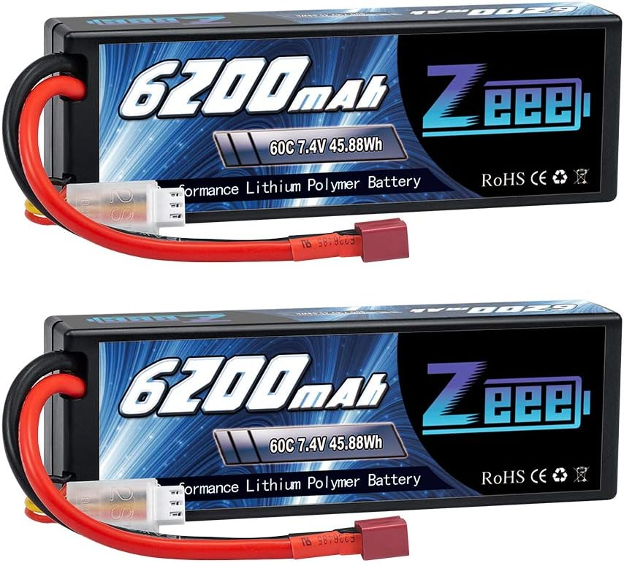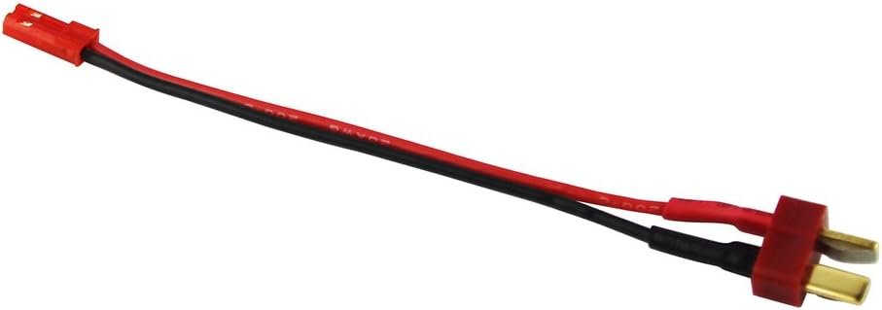

1. Connect the battery adapter cable shown above on the right into the connector attached to the red and black wires of the battery.
2. Use the male-to-male Dupont wires (shown below) to connect the red (positive) and black (negative) wires to the LM2596 DC-DC Buck Converter, either directly or by using a breadboard.

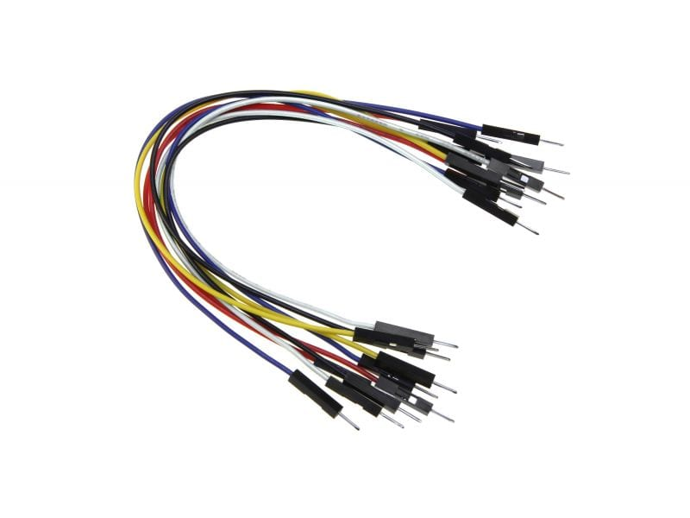

1. Follow the instructions on the included “Setting the Voltage Regulator” document.
2. Once the voltage regulator is properly set to 3.3V, connect the positive and negative “OUT” pads to the 3.3V and GND pins on the ESP32.

**Do not connect the battery directly to the ESP32, without using a properly set voltage regulator (buck converter). If you do, the magic smoke will escape.**